**HoYoShade User Agreement (updated on 2024/06/27)**

**Author:** DuolaDStudio Hong Kong Ltd.

**Foreword**

Thank you for choosing to download and use HoYoShade. Before proceeding, we ask that you carefully read and understand all terms of this user agreement. If you decide to continue using HoYoShade, it is deemed that you have agreed to and accepted all the terms of this agreement. If you do not agree with any of the terms in this agreement, please immediately stop using HoYoShade.

**Agreement Updates**

We reserve the right to update this agreement at any time.

Any updates to this user agreement will automatically apply to all versions of HoYoShade. Please regularly check our announcements to stay informed of any changes. Users who fail to review the latest user agreement in a timely manner will not be notified separately.

**Terms & Conditions**

1. **Risk Notice**: You should understand that using mods in HoYoShade may pose risks to your Mihoyo/Hoyoverse game account, including but not limited to account bans or other adverse consequences. In such cases, the developers of HoYoShade and all secondary developers bear no responsibility.
2. **Prohibition of Misappropriation**: Without the explicit permission of the original developer "哆啦D夢|DuolaD", you are not allowed to misappropriate or integrate any effect libraries from the reshade-shader folder in HoYoShade into other ReShades.
3. **Prohibition of misappropriation** **Content Citation**: Without the explicit permission of the original developer "哆啦D夢|DuolaD", you are not allowed to misappropriate or integrate any effect libraries from the reshade-shader folder in HoYoShade into other ReShades.
4. **Content Citation**: When using HoYoShade to capture materials in-game and publish videos, you need to clearly state: "This video was rendered with support from GitHub@DuolaD/HoYoShade" in the video or on the related publishing platform, or directly mention and thank the account "哆啦D夢|DuolaD". If due to special reasons (such as Mihoyo's creative incentive plan, MCN institutions, or platform restrictions) you cannot directly mark it, you need to contact the original developer in advance for an explanation and get approval on whether you can omit the marking. Once the special reasons no longer exist, you must re-mark it yourself.

**Again**, if you do not accept any of the terms of this Agreement, please stop using HoYoShade immediately.

**Important Tips**

* For your safety, we only recommend using the releases we issue for Mihoyo games. Anyone can use the OpenHoYoShade framework for secondary development and achieve other/more functions, but we do not conduct security reviews for these secondary development versions. If you choose to use non-official HoYoShade versions developed and released by others, you are responsible for all potential security issues.
* Mihoyo/Hoyoverse's attitude towards mods is relatively ambiguous. Although mods are officially prohibited, in practice, as long as they do not involve cheating or openly challenging the official stance, users' accounts usually won't be penalized. However, any consequences resulting from using mods are solely your responsibility.
* Before sending game content to others or live streaming, HoYoShade recommends hiding your game UID and user information using other mods and not displaying HoYoShade or other mod interfaces to anyone else.
* HoYoShade recommends updating your graphics card and chipset drivers to the latest versions (if available) to receive the latest support from your device manufacturer, reducing graphical issues and game crashes.
* We do not recommend running HoYoShade on official servers.
* For Mihoyo/Hoyoverse developer beta versions and creator experience server clients (usually client version number: current version number.5.X), HoYoShade theoretically can provide injection and running support. However, we do not recommend using beta clients and/or creator experience server clients on official servers to avoid confidentiality agreement breaches, violations, legal issues, or economic losses.
* HoYoShade developers and secondary developers will not bear any responsibility for any consequences that may occur.

**Final Interpretation**

The interpretation right of this user agreement belongs to the developers of HoYoShade. If you have any questions or disputes, please contact us for communication and resolution.

Thank you for your understanding and cooperation, and enjoy using HoYoShade!

From all members of DuolaDStudio Hong Kong Ltd.

**HoYoShade Installation Guide (Updated 2024/06/27)**

**Author:** DuolaDStudio Hong Kong Ltd.

**Suggestion: Close or configure antivirus software before operation**

1. Before/after injecting the game with the launcher, it is recommended to close antivirus software to avoid unnecessary interference. If the operation is intercepted or files are deleted by antivirus software, please restart the operation and add the related folder to the antivirus software's whitelist.
2. After completing the operation, ensure all files in HoYoShade are added to the antivirus software's whitelist to prevent being mistakenly deleted or intercepted.
3. If you must operate with antivirus software on, add the extracted folder to the antivirus whitelist, and allow the operation to continue if files are intercepted or deleted.
4. Unless explicitly required by the developer or you know exactly what you are doing, do not arbitrarily delete files generated by HoYoShade. These files are usually located in specific folders (not in the game root directory).

**Step 1: Download and Preparation**

1. Download the latest version of HoYoShade from the official release page of HoYoShade.
2. Extract the downloaded zip file and open the extracted folder.

**Step 2: Launch the launcher**

1. In the mod folder, choose the language you are familiar with to launch the launcher (double-click to open, no need for administrator privileges).

The following languages are currently supported:

* + Chinese Simplified
  + Chinese Traditional
  + English

**Step 3: Initialize HoYoShade and Install ReShade.ini**

1. When launching the launcher for the first time, a configuration file named ReShade.ini will be generated in the mod root directory.
2. Follow the launcher's prompts to find the game process root directory and copy ReShade.ini to the game process root directory. Once copied, the initialization step is complete.

Graphical user interface, text, applications

The description is automatically generated

**How to find the game process root directory?**

— For HoYoPlay:

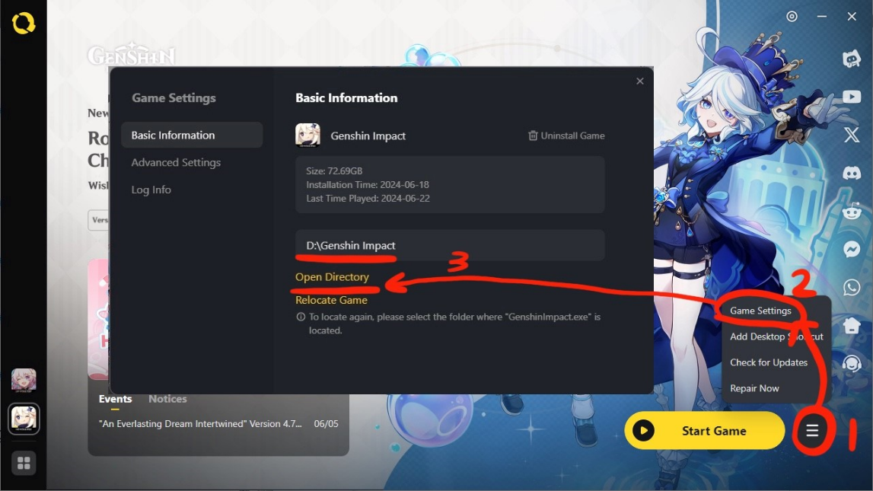

* + Click the more icon next to the start button - game settings to view the game process root directory.
  + Click 'Open Directory' to open the root directory of the game process using the explorer.

— For StarWard:

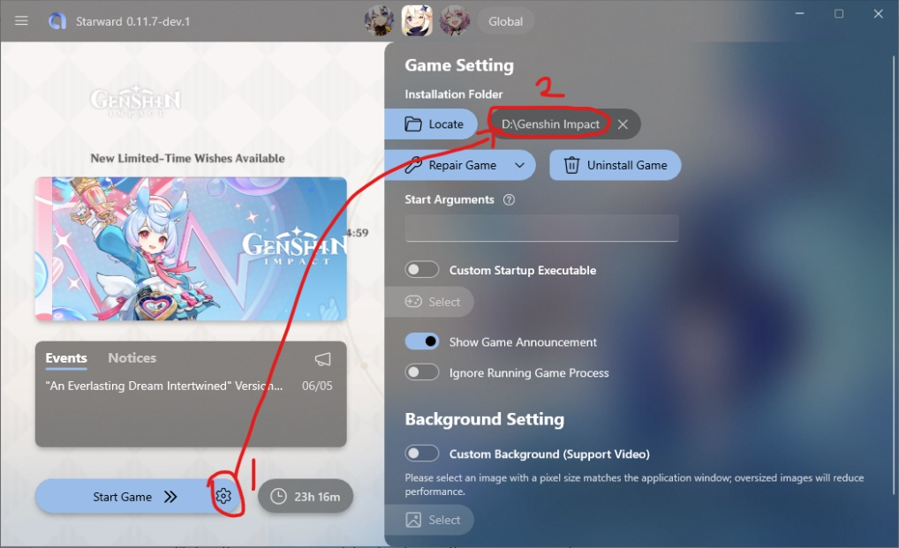

* + Click the gear icon next to the start button to view the game process root directory.
  + Click the game process root directory to use the file explorer to open the game process root directory.

Ensure that the directory contains the game process files.

(e.g. :YuanShen.exe, GenshinImpact.exe, BH3.exe, StarRail.exe, ZZZ.exe).

**Step 5: Inject HoYoShade into the Target Client**

**Ensure the game process is closed.**

1. Select the correct client to start the injection program on the launcher homepage.
2. Select the correct client to start the injection program on the launcher homepage.
3. After the injector prompts "waiting for the game to start", start the game using the launcher.

(Using a shortcut or directly double-clicking the game process may cause injection failure)

(Selecting the wrong target client will result in failure to inject/the injector not responding to the game)

**Notes:**

1. In general, most FPS unlockers require you not to change the frame rate settings in the game while using the FPS unlocker.
2. For games not listed in the supported games list, you can try selecting supported games in the injector or use custom injection in developer options to attempt injecting HoYoShade.
3. HoYoShade supports simultaneous injection with other mainstream mods without any conflict issues. However, ensure that other game mods do not conflict with each other.
4. If you are using multiple mods injected into the game and one mod automatically starts the game, start the mod that automatically starts the game last after other mods prompt waiting for injection.

Following these steps, you should be able to successfully install and use HoYoShade. If you have any questions or encounter problems, please contact the developer.

Enjoy using HoYoShade!

From all members of DuolaDStudio Hong Kong Ltd.

**Contact:**

If you have any questions, feel free to contact us through the following contact information. If you cannot reach us through the contact information below, it means the developer's contact information may have been updated. Please visit the developer's GitHub page for the latest contact information.

**Join our communication group:**

Mainland China:

QQ group [377103253].

Overseas:

Discord[https://discord.gg/FYVUxwa5RF]

Telegram[https://t.me/DuolaDStudio]

**Main developer: 哆啦D夢|DuolaD**

GitHub Pages [https://github.com/DuolaD].

WeChat/Douyin[GitHub_DuolaD]

QQ[3484767759]

E-mail[D_mou@outlook.com]

HoYoLAB:[https://www.hoyolab.com/accountCenter/postList?id=192633110]

Telegram:[https://t.me/GitHub_DuolaD]

**琳尼特|LynetteNotFound has no public contact information, beware of scams.**

Enjoy using HoYoShade!

From all members of DuolaDStudio Hong Kong Ltd.